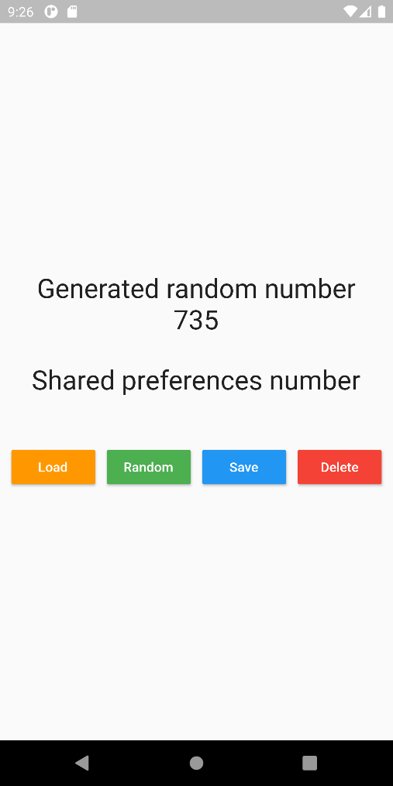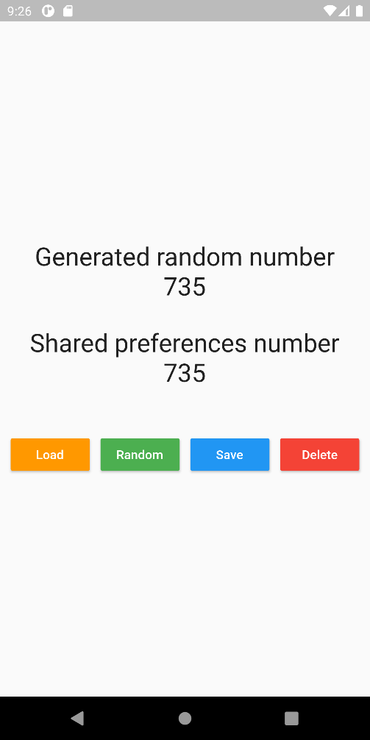

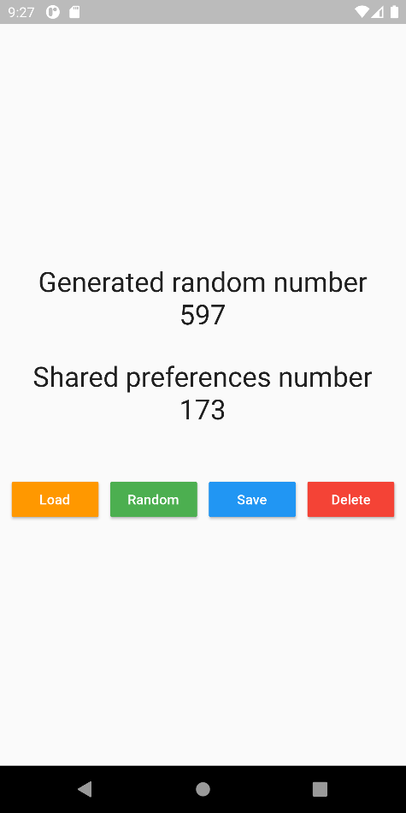

# Code

import 'dart:math';  
  
import 'package:flutter/material.dart';  
import 'package:shared_preferences/shared_preferences.dart';  
  
void main() {  
 runApp(MyApp());  
}  
  
class MyApp extends StatelessWidget {  
 @override  
 Widget build(BuildContext context) {  
 return MaterialApp(  
 debugShowCheckedModeBanner: false,  
 home: MyHomePage(),  
 );  
 }  
}  
  
Future<int> getSharedPrefsInt() async{  
 final prefs = await SharedPreferences.*getInstance*();  
 return prefs.getInt("integerValue");  
}  
  
Future removeSharedPrefsInt() async {  
 final prefs = await SharedPreferences.*getInstance*();  
 await prefs.remove("integerValue");  
}  
  
Future saveSharedPrefsInt(int newInt) async {  
 final prefs = await SharedPreferences.*getInstance*();  
 await prefs.setInt("integerValue", newInt);  
}  
  
class MyHomePage extends StatefulWidget {  
 @override  
 _MyHomePageState createState() => _MyHomePageState();  
}  
class _MyHomePageState extends State<MyHomePage> {  
 int randomNumber;  
  
 @override  
 void initState() {  
 super.initState();  
 randomNumber = Random().nextInt(1000);  
 }  
  
 @override  
 Widget build(BuildContext context) {  
 return Scaffold(  
 body: SafeArea(  
 child: Center(  
 child: Column(  
 crossAxisAlignment: CrossAxisAlignment.center,  
 mainAxisAlignment: MainAxisAlignment.center,  
 children: [  
 Text("Generated random number", style: TextStyle(fontSize: 28),),  
 Text(randomNumber.toString(), style: TextStyle(fontSize: 28),),  
 SizedBox(height: 30,),  
 Text("Shared preferences number", style: TextStyle(fontSize: 28),),  
 FutureBuilder(  
 future: getSharedPrefsInt(),  
 builder: (context, snapshot){  
 if (snapshot.hasData){  
 return Text(snapshot.data.toString(), style: TextStyle(fontSize: 28),);  
 }  
 else {  
 if (snapshot.hasError) print(snapshot.error);  
 return SizedBox.shrink();  
 }  
 },  
 ),  
 SizedBox(height: 50,),  
 Row(  
 mainAxisAlignment: MainAxisAlignment.spaceEvenly,  
 children: [  
 RaisedButton(  
 color: Colors.*orange*,  
 textColor: Colors.*white*,  
 child: Text("Load"),  
 onPressed: (){setState(() {});},  
 ),  
 RaisedButton(  
 color: Colors.*green*,  
 textColor: Colors.*white*,  
 child: Text("Random"),  
 onPressed: (){setState(() {randomNumber = Random().nextInt(1000);});},  
 ),  
 RaisedButton(  
 color: Colors.*blue*,  
 textColor: Colors.*white*,  
 child: Text("Save"),  
 onPressed: () async {  
 await saveSharedPrefsInt(randomNumber);},  
 ),  
 RaisedButton(  
 color: Colors.*red*,  
 textColor: Colors.*white*,  
 child: Text("Delete"),  
 onPressed: () async {  
 await removeSharedPrefsInt();}  
 )  
 ],  
 ),  
 ],  
 ),  
 ),  
 ), // This trailing comma makes auto-formatting nicer for build methods.  
 );  
 }  
}